# Brief

Motivated by [Genuary](https://genuary2021.github.io/prompts), a set of prompts for creating generative art throughout the month of January, your goal is to share one original generative art piece (sketch), along with its code, on Piazza each week. In total, you’ll share 7 sketches by Spring Break.

For the purposes of this class, the week ends **Friday, 10pm Eastern time**. To fully enumerate the deadlines for Spring ‘22, they are:

* January 21
* January 28
* February 4
* February 11
* February 18
* February 25
* March 4

No sketch will be due on March 9; instead, you’ll submit your mid-semester reflection.

# Prompts

Each of your sketches must correspond to a different prompt drawn from the list below. Many of the prompts are deliberately vague; it’s up to you to decide how to interpret them. When you post your sketch to Piazza, make sure to include the prompt number. Numbers correspond to prompts as follows:

1. Triple nested loops
   1. Using an image as a height map to triple loop through and draw height lines
   2. Draw deep space photo by having double-nested loop for position and a 3rd loop for depth and chance placement of elipses
2. Draw a line. Wrong answers only.
   1. ???
3. Include and use the following function:

|  |
| --- |
| function f(x) {  DRAW(x);  f(1 * x / 4);  f(2 * x / 4);  f(3 * x / 4);  } |

1. Make a grid of at least 100 permutations of something
2. Use sound.
3. Any shape, none can touch.
4. Replicate a natural concept (e.g. gravity, flocking, path following)
5. A natural landscape that reminds you of home
6. 500 lines
7. Cellular automata
8. Radial symmetry
   1. Snowflakes, paper folding
9. Come up with some rules, then follow them by hand on paper.
10. Human faces
11. Noise and/or interference patterns
12. Shape grammars or L-systems
    1. https://www.vexlio.com/blog/drawing-simple-organics-with-l-systems/
13. Text
    1. See, e.g., [concrete poetry](https://www.britannica.com/art/concrete-poetry)
14. One process grows, another process prunes.
15. Increase the randomness along the Y-axis.
16. No loops.
17. Monochrome gradients without lines.
18. Code Golf: How little code can you write to make something interesting?
19. Use an API (e.g. the weather). [Here’s a huge list of free public APIs](https://github.com/public-apis/public-apis).

# Sharing Processing/p5.js Sketches

To save and share sketches on p5.js, you will need to either create an account on the [p5.js website](https://p5js.org/) or have a [github](https://github.com/) account created already. Use these credentials to log in to the p5.js website before you edit.

When you’re ready to share your creation and code, go to **File -> Share**, and copy the **Edit link** to paste into your Piazza post.

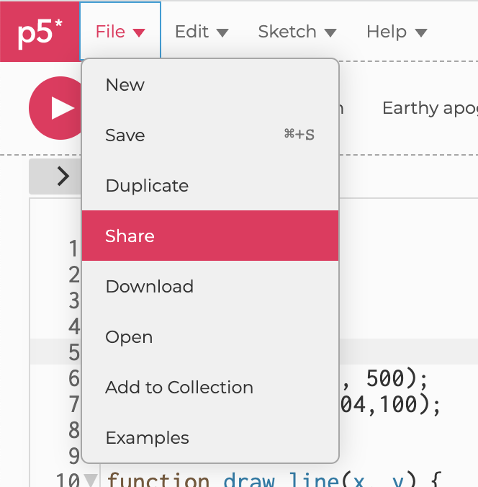 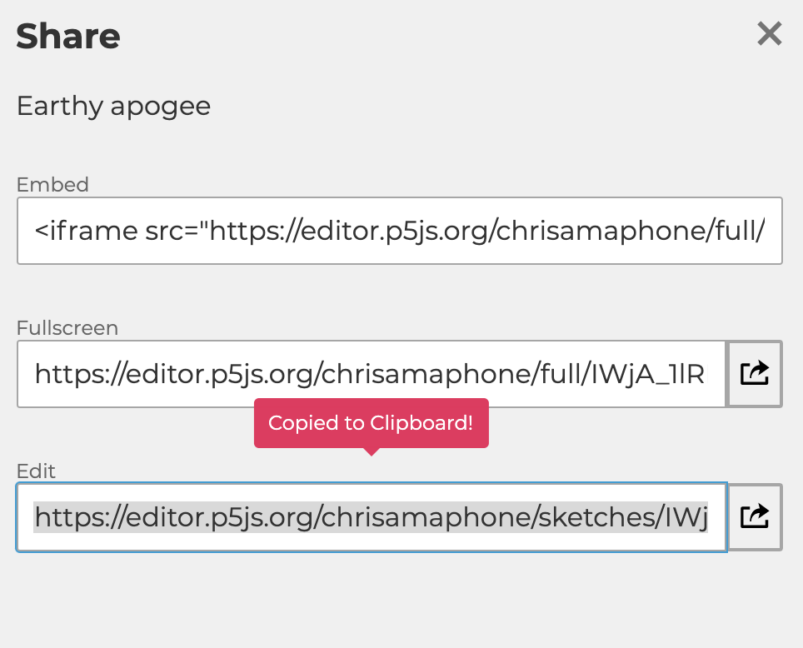

If you use the standalone Processing tool, you’ll need to create a github account (or use your NCSU Enterprise one), make a public (or NCSU-restricted) repository for your sketches, and push your code so you can link to it from Piazza.

# Posting Your Sketch to Piazza

Make a **note** post to Piazza, either instructors-only or to the whole class (your choice), with the following specifications:

* **Folders**: make sure to select the **weeklysketch** folder for your post.
* **Summary\*** (subject line): should be of the form  
   **Sketch #S, Prompt #P (<yourunityID>)**  
  Where S indicates how many sketches total you’ve shared, including this one, and P is the number corresponding to the prompt you followed (see prompts list below).  
  Example: If I’m posting my 4th sketch using Prompt 11 (radial symmetry), my subject would be  
   **Sketch #4, Prompt 11 (crmarten)**
* **Body**: Your message should contain:
  + A link to your p5.js code at the very top.
  + The text of the prompt.
  + A few sentences explaining how you interpreted the prompt, what your goal was, how you approached it, and any adjustments you made along the way.
  + 1-4 screenshots showing what your code generates.

*It’s VERY IMPORTANT to get the subject line right, as I’ll be using searches to filter out Piazza posts and see the work you’ve contributed!

Here’s a screenshot example of what a draft post should look like:

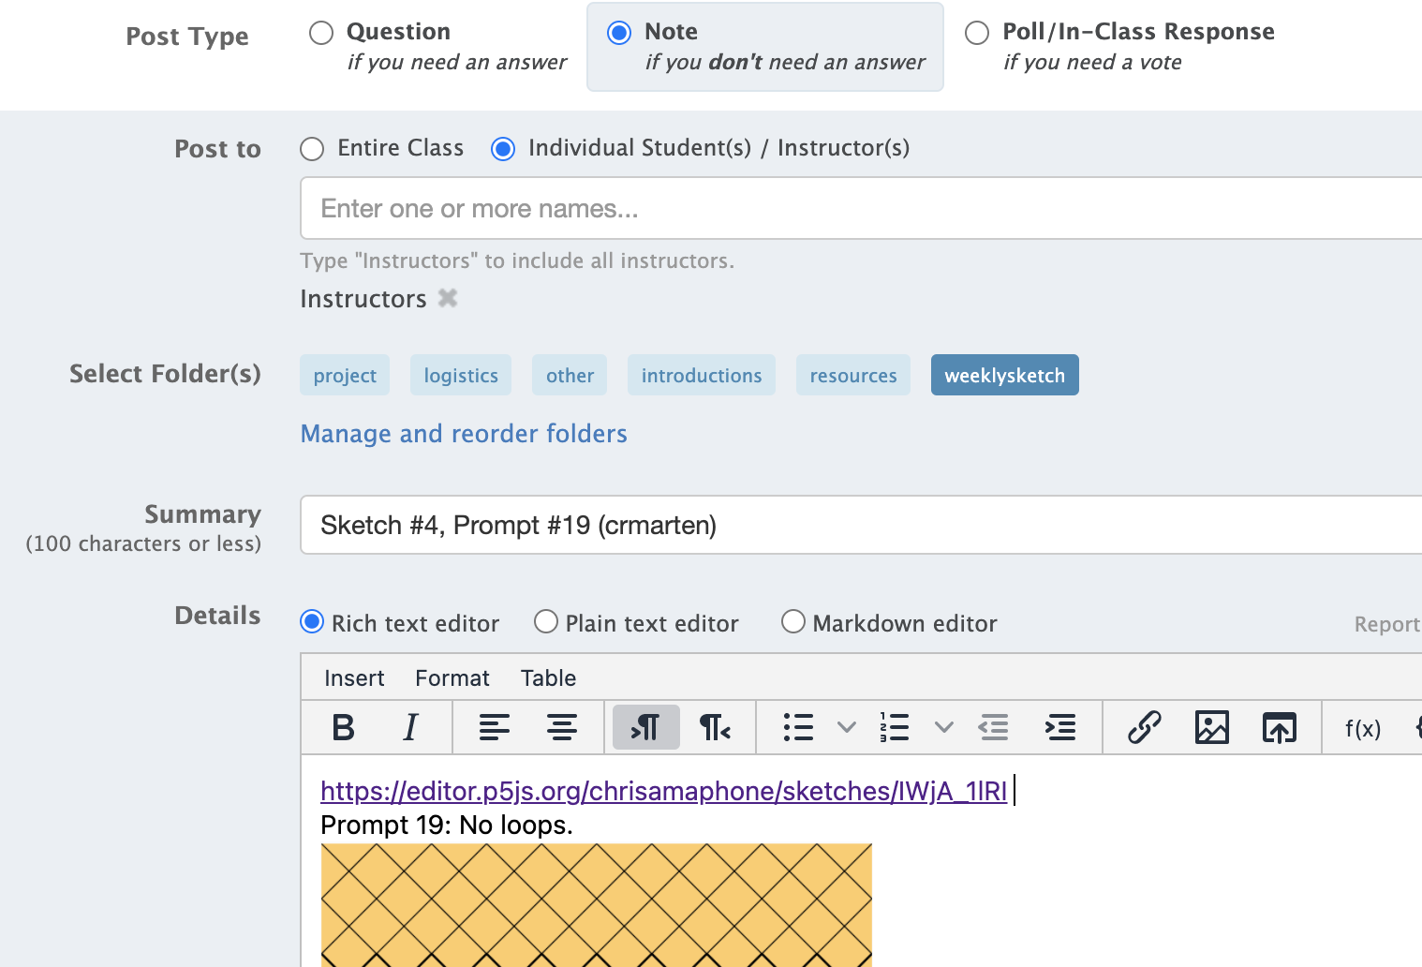

## Commenting on Classmates’ Sketches

If someone shares their work with the whole class, I encourage you to leave them comments. Critique is welcome, but please be respectful! Here are some guidelines for giving your classmates constructive, respectful feedback on their work:

* Take a moment to really study the piece and its code before commenting. Examine your subjective reaction and any associations you might have to your personal memories (does the pattern remind you of a sunset, or your grandmother’s carpet?), but also try to formulate objective observations, like you’re trying to describe the piece to someone who can’t see it.
* If you like what they did, get specific about **what** you like. For example, don’t just say “looks cool!,” say, “the way the lines overlap creates a really striking contrast between the foreground and background.”
* Similarly, if you think the piece is boring, unimaginative, or unappealing in some way, get specific about **what** doesn’t work for you. Try not to give them specific advice based on what you would do, but instead describe the cause-and-effect relationship between their choices for the piece and the effects it has on you. For example, instead of saying “This is kind of dull - try adding some color!”, you could say “the greyscale palette doesn’t grab my attention; my eyes can’t figure out where to focus.”
  + Always make sure your comments are about the **work** and not the **person** who created it. Personal insults will not be tolerated.
* You can comment on many different aspects of the work, including:
  + The code
  + The appearance of the results shown in the screenshots
  + The way the results change, move, or animate in the rendered version
  + The relationship between this piece and the student’s prior work, noticing recurring themes or improved skill across multiple pieces.

# Getting Inspiration

Aside from checking out your classmates’ posts, you can also search your favorite social media site (e.g. Instagram, Twitter, Tumblr) for the #genuary hashtag, or do a google search for “genuary generative art”. Here are a few examples I’ve come across:

* <https://ram-n.github.io/Genuary_2021/>
* From Tiktok user [Ayliean](https://www.tiktok.com/@ayliean), a Scottish maths/art creator: [https://www.tiktok.com/@ayliean/video/7048733728142609670](https://www.tiktok.com/@ayliean/video/7048733728142609670?is_copy_url=1&is_from_webapp=v1)